Date: 23.08.2024
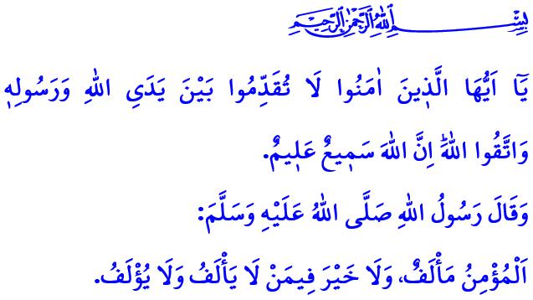
THE PROPHET MUHAMMAD (SAW): OUR GUIDE IN ETIQUETTE
Dear Muslims!
Our Lord Almighty (swt) states in the first couple of verses of Surah al-Hujurat, “O believers! Do not proceed in any matter before a decree from Allah and His Messenger. And fear Allah. Surely Allah is All-Hearing, All-Knowing. O believers! Do not raise your voices above the voice of the Prophet, nor speak loudly to him as you do to one another, or your deeds will become void while you are unaware.”
These verses inform us that the judgments of Allah and His Messenger (saw) are more important and valuable than our decisions, preferences, opinions and thoughts. They remind us that our attitudes, behaviors and actions should be in accordance with the commands of Allah and His Messenger (saw). They advise that we should apply the sunnah of our Prophet (saw) to every aspect of our lives.
Dear Believers!
The example set for us by our beloved Prophet (saw) is not limited to the principles of faith and worship. The Messenger of Allah (saw) is our guide also in our social relations that we refer to as etiquette. It is the set of rules of courtesy and manners commanded by our Almighty Lord (swt) and exemplified by our Prophet (saw), which establish social peace and harmony.
Every good deed, eating and drinking begins with “Basmala” and ends with “Alhamdulillah” in the exemplary life of our Prophet (saw). He (saw) said that the way to love was through greetings, and he greeted his family, children, young people, old people, and everyone familiar or unfamiliar. Greeting also acquires the status of worship and supplication when it is exchanged in the manner taught by the Messenger of Allah (saw). One of the beautiful names of Allah is “al-Salam”. Salam is the common password among Muslims. It helps to increase compassion and mercy, peace and prosperity among people. The greeting we extend on our departure from a meeting is no different from the greeting we extend on our arrival.
Our Prophet (saw) says, “Whoever believes in Allah and the Last Day should speak what is good or keep silent.” and asks us to always speak what is good and kind. He (saw) would not speak loudly so as to be a nuisance to people, nor would he interrupt people. He (saw) would never make a promise he could not keep, and he would always keep what he promised. He has strictly forbidden spying on other people’s homes, secretly listening to other people’s conversations, and investigating people’s private lives. Our beloved Prophet (saw) was always a compatible person and advised us as follows: “The believer befriends and is befriended. There is no good in those who do not befriend or be befriended.”
Dear Muslims!
According to our sublime religion, Islam, there is also a code of conduct for paying a visit. It is a social convention to inform the person we are going to visit in advance, to ask for permission to enter the house, and to return if the people who are there are not available. It is a social convention not to raise our voices against our elders and parents, to treat our spouses with kindness and grace, and to show mercy to those who are younger than us. It is a social convention to treat our guests well and to avoid words and actions that may disturb our neighbors. It is also a social convention to avoid behaviors prohibited by Islam, such as lying, slandering, distorting, bragging and violating the boundaries of privacy on the social media platforms we use so much today, and to act with the awareness that Allah the Almighty sees and hears us in the online world, too.
Let us strive to make the rules of etiquette taught by the Messenger of Allah (saw) dominant in every aspect of our lives. Let us show the necessary sensitivity for our children to choose the courses of Etiquette, the Holy Qur’an, the Life of our Prophet and Basic Religious Knowledge in the curriculum. Let us be sensitive in this regard so that Allah, our Prophet (saw), our family and our environment may be pleased with us, our world may be filled with peace and happiness, and our Hereafter may be paradise.
Dear Believers!
As I conclude this Friday’s khutbah, I would like to commemorate with mercy our beloved martyrs and our deceased heroic veterans in these days as we enter the Victory Week, and I would like to remind a point again. We have been fighting forest fires for some time now. There is still a risk of fire. Therefore, let us stay away from behaviors that can cause fires in open areas, especially in our forests. Let us pay attention to the warnings of the authorities. May Allah the Almighty protect our country and nation from all kinds of disasters and calamities.

Hujurat, 49/1, 2.
Muslim, Iman, 93.
Tirmidhi, Isti’dhan, 15.
Bukhari, Adab, 3.
Ibn Hanbal, II, 400. General Directorate of Religious Services

